**Samarth Agrawal**

**2380266**

**JAVA HANDSON**

**1: Create a class with a method which can calculate the sum of first n natural numbers which are divisible by 3 or 5.**

package com.assign2;

import java.util.Scanner; public class NaturalNum { public static void main(String[] args) {

Scanner sc=new Scanner(System.in); System.out.println("Enter the number: ");

int number=sc.nextInt(); NaturalNum obj= new NaturalNum(); int result=obj.calculateSum(number);

System.out.println("The sum of Natural Number which is Divisible by 3 or 5 is: "+result);

}

public int calculateSum(int number)

{

int sum=0;

for(int i=1;i<=number;i++)

{

if(i%3==0 || i%5==0)

{

sum+=i;

}

}

return sum;

}

}

**OUTPUT:**

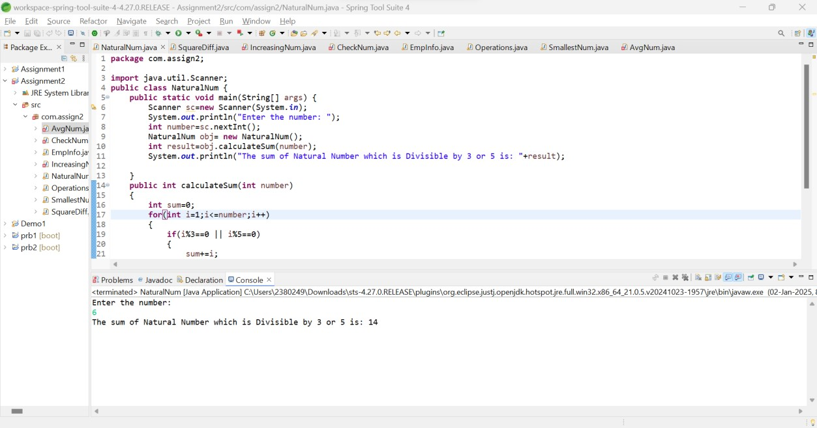

**2: Create a class with a method to find the difference between the sum of the squares and the square of the sum of the first n natural numbers.**

package com.assign2; import java.util.Scanner;

public class SquareDiff {

public static void main(String[] args) {

Scanner sc=new Scanner(System.in); System.out.println("Enter the Number:");

int number=sc.nextInt();

System.out.println("The difference between the sum of the Squares of the

first n natural numbers and the Square of their sum is: "+(calculateDifference(number)));

}

public static int calculateDifference(int number)

{

int sumOfSquares=0,sum=0,result=0; for(int i=1;i<=number;i++)

{

sumOfSquares=sumOfSquares+(i*i);

sum+=i;

}

result=sumOfSquares-(sum*sum);

return result;

}

}

**Output:**

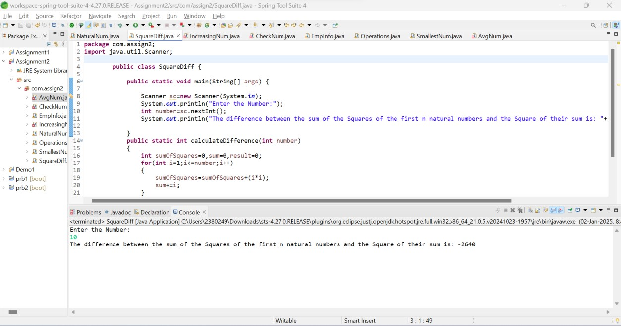

**3: Create a method to check if a number is an increasing number.**

package com.assign2; import java.util.Scanner;

public class IncreasingNum {

public static void main(String[] args) {

Scanner sc=new Scanner(System.in); System.out.println("Enter the Number:"); int number =sc.nextInt();

boolean result=checkNumber(number);

if(result)

{

System.out.println(number+" is an increasing number");

}

else {

System.out.println(number+" is not an increasing number");

}

}

public static boolean checkNumber(int number)

{

while(number>0)

{

int number1=number%10;

number/=10;

int number2=number%10;

if(number1<number2)

{

return false;

}

}

return true;

}

}

**Output:**

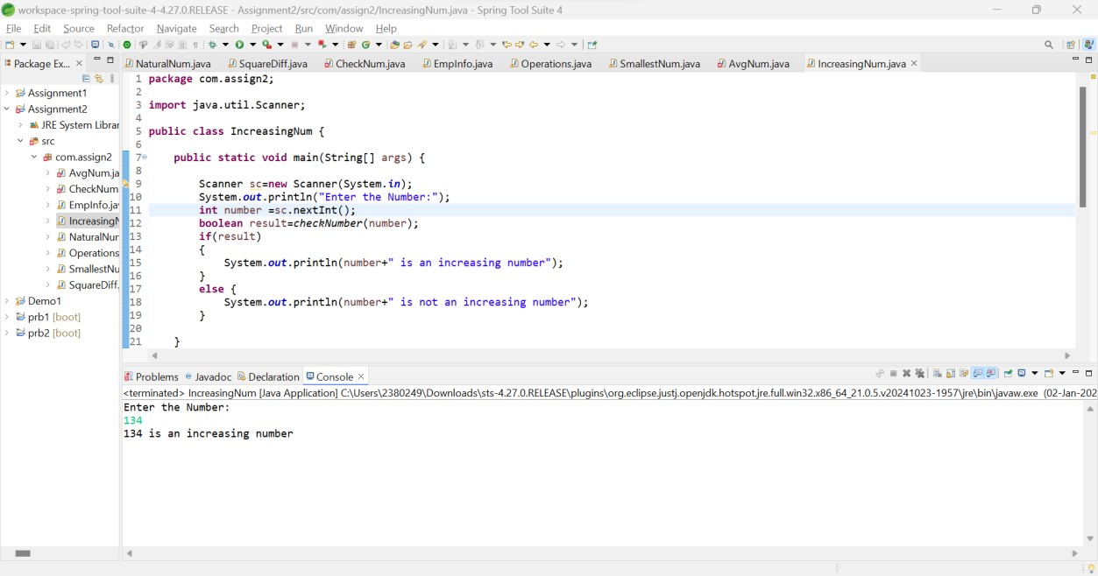

**Exercise 4: Create a method to check if a number is a power of two or not.**

package com.assign2; import java.util.Scanner; public class CheckNum {

public static void main(String[] args) {

public class CheckNum{

public static void main(String[] args) {

Scanner sc=new Scanner(System.in); System.out.println("Enter the Number: "); int number=sc.nextInt(); CheckNum obj=new CheckNum();

boolean result=obj.checkNumber(number);

if(result)

{

System.out.println(number+" is a Power of 2");

}

else {

System.out.println(number+" is not a Power of 2");

}

}

public boolean checkNumber(int number)

{

int i=1,res=0;

while(true)

{

int j=0,sum=1;

while(j<i)

{

sum*=2;

j++; }

i++;

if(sum>=number)

{

res=sum; break;

}

}

if(res==number)

{

return true;

}

else {

return false;

}

}

}

**Output:**

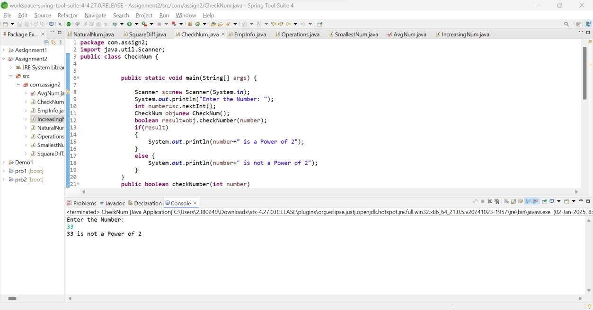

5:Take Employee Info like empid, empname, empsal, empAdd, empGender, empEmail and display .

package com.assign2; import java.util.Scanner; public class EmpInfo {

public static void main(String[] args) {

Scanner sc=new Scanner(System.in);

System.out.println("Enter the Employee Id: ");

int empId=sc.nextInt();

sc.nextLine();

System.out.println("Enter the Employee Name: ");

String empName=sc.nextLine();

System.out.println("Enter the Employee's Salary: ");

double empSalary=sc.nextDouble();

sc.nextLine();

System.out.println("Enter the Employee Address: "); String empAdd=sc.nextLine();

System.out.println("Enter the Employee Gender (M/F): ");

char empGender=sc.next().charAt(0);

sc.nextLine();

System.out.println("Enter the Employee's Email: ");

String email=sc.nextLine();

System.out.println("================================================================== ==========");

System.out.println("Employee's Id is: "+empId);

System.out.println("Employee's Name is: "+empName.toUpperCase());

System.out.println("Employee's Salary is: "+empSalary);

System.out.println("Employee's Address is: "+empAdd);

System.out.println("Employee's Gender is: "+empGender);

System.out.println("Employee's Email is: "+email);

}

}

**Output:**

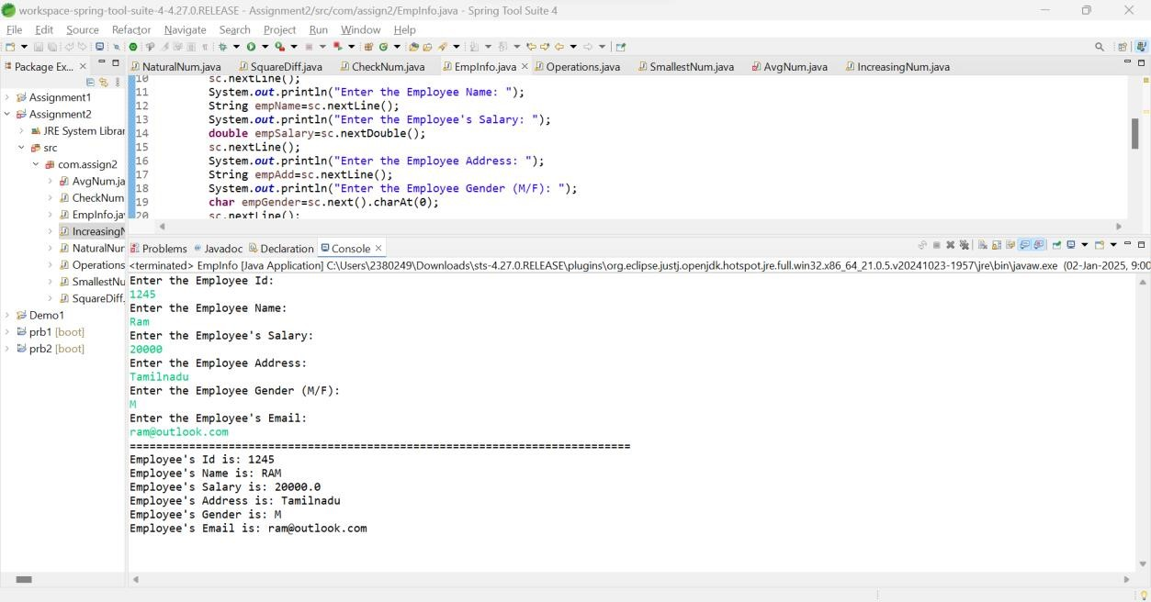

**6: Write a Java program to print the sum (addition), multiply, subtract, divide and remainder of two numbers.**

package com.assign2; import java.util.Scanner;

public class Operations {

public static void main(String[] args) {

Scanner sc=new Scanner(System.in); System.out.println("Enter the First Number:");

int number1=sc.nextInt();

System.out.println("Enter the Second Number:");

int number2=sc.nextInt();

int sum=number1+number2; int sub=number1-number2; int mul=number1*number2; int div=number1/number2; int modulos=number1%number2;

System.out.println("The Addition Of 2 Numbers is: "+sum);

System.out.println("The Addition Of 2 Numbers is: "+sub);

System.out.println("The Addition Of 2 Numbers is: "+mul);

System.out.println("The Addition Of 2 Numbers is: "+div);

System.out.println("The Addition Of 2 Numbers is: "+modulos);

}

}

**Output**

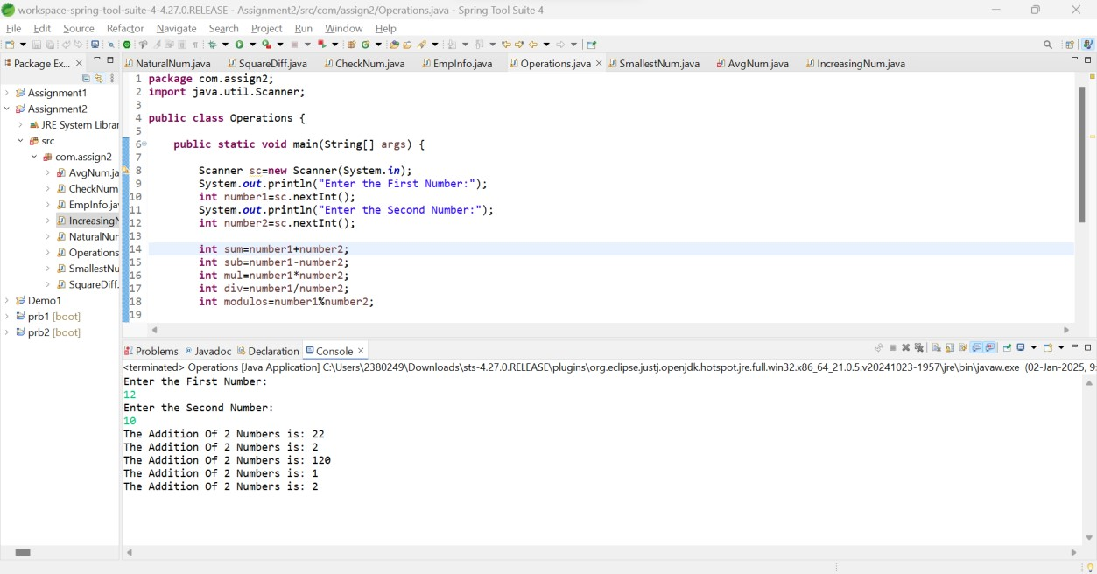

**7: Write a Java method to find the smallest number among three numbers.**

package com.assign2; import java.util.Scanner;

public class SmallestNum { public static void main(String[] args) {

Scanner sc=new Scanner(System.in);

System.out.println("Enter the First Number:");

int number1=sc.nextInt();

System.out.println("Enter the Second Number:");

int number2=sc.nextInt();

System.out.println("Enter the Third Number:");

int number3=sc.nextInt();

float result=findSmallestNumber(number1,number2,number3);

System.out.printf("The Smallest Value is: %.1f",result);

}

public static float findSmallestNumber(int number1, int number2,int number3)

{

if((number1<number2) && (number1<number3))

{

return number1;

}

else if((number1>number2) && (number2<number3))

{

return number2;

}

else {

return number3;

}

}

}

**Output:**

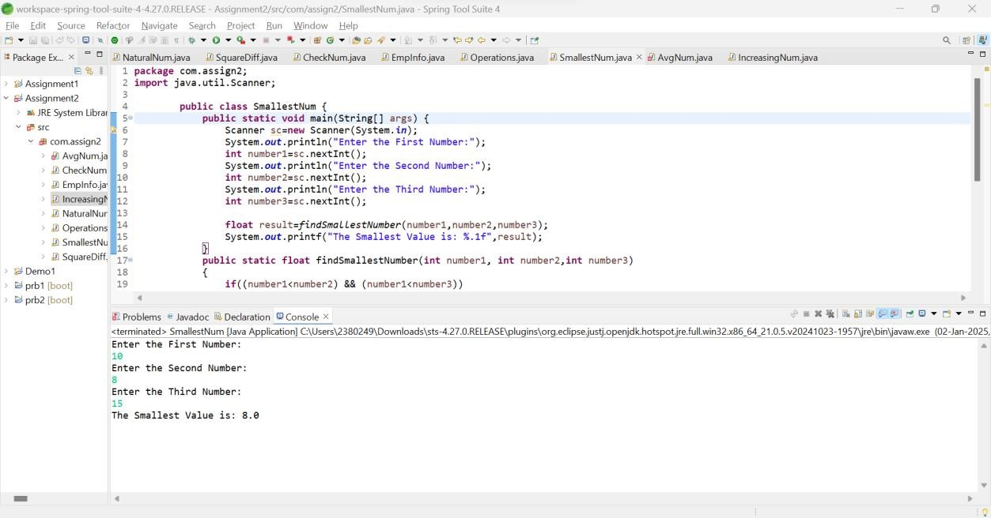

**8: Write a Java method to compute the average of three numbers.**

package com.assign2; import java.util.Scanner;

public class AvgNum {

public static void main(String[] args) {

Scanner sc=new Scanner(System.in);

System.out.println("Enter the First Number:");

int number1=sc.nextInt();

System.out.println("Enter the Second Number:");

int number2=sc.nextInt();

System.out.println("Enter the Third Number:");

int number3=sc.nextInt();

AvgNum obj=new AvgNum();

float result=obj.averageNumber(number1,number2,number3);

System.out.printf("The Average of 3 numbers is: %.2f",result);

}

public float averageNumber(int number1, int number2,int number3)

{

return (number1+number2+number3)/3;

}

}

**Output:**

